Use this pin number configuration.

10 9 8 7 6

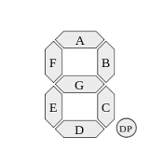

1 2 3 4 5